Heart worksheet - simplified diagram
TASK 1:
Cut and paste the following picture of the heart (simplified) into the centre of a page in your note book (you need some space around the outside to put labels)
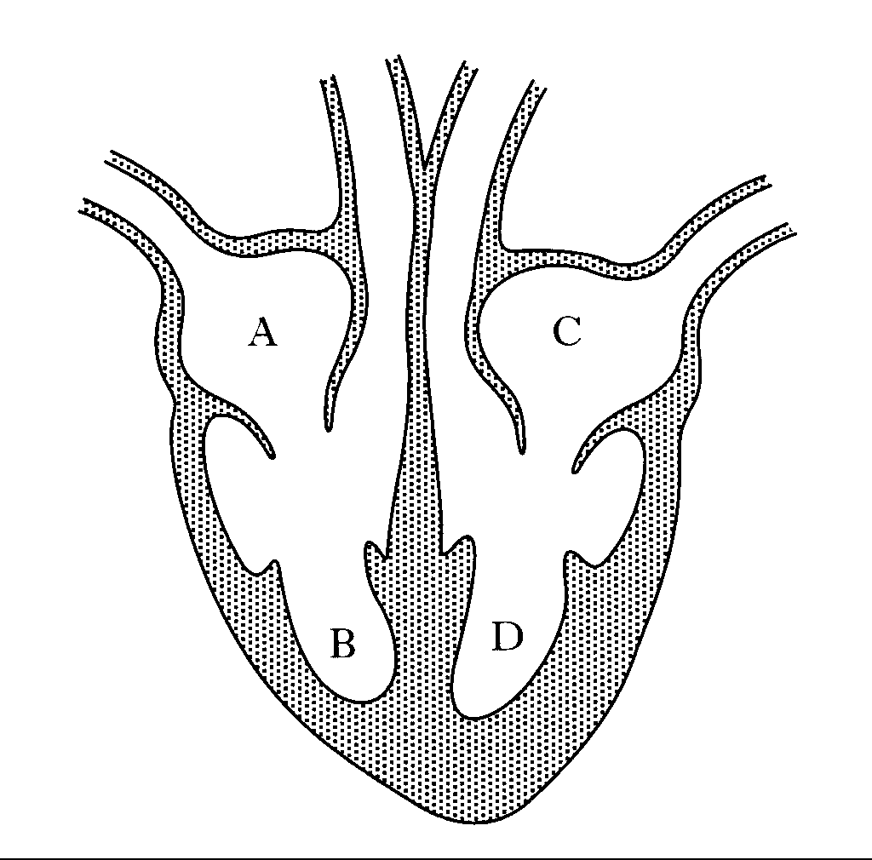
TASK 2:
Using a more complex diagram of the heart as a guide or your teachers’ instruction, label each of the four internal chambers of the heart with its correct name
- Left Atrium
- Left Ventricle
- Right Atrium
- Right Ventricle
Task 3:
Cut and paste in the diagram below explaining blood flow through and around the heart.
Task 4:
Using a more complex diagram of the heart as a guide or your teachers’ instruction, draw arrows showing the flow of blood through the heart.

Task 5: On your heart diagram, label the four main blood vessels at the top of the heart. You can use the clues in the flowchart to name them. Check with your teacher to make sure you are correct.

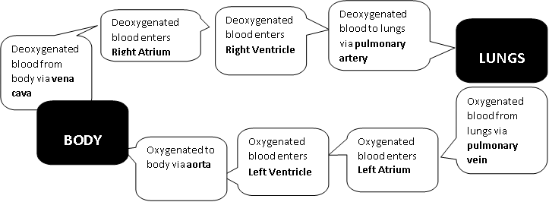
Deoxygenated blood from body via vena cava

LUNGS

BODY
Oxygenated to body via aorta
Oxygenated blood enters LV
Oxygenated blood enters LA
Deoxygenated blood to lungs via pulmonary artery
Deoxygenated blood enters R.V.
Deoxygenated blood enters R.A.

LUNGS

BODY
Oxygenated to body via aorta
Oxygenated blood enters LV
Oxygenated blood enters LA

Oxygenated blood from lungs via pulmonary vein
Deoxygenated blood to lungs via pulmonary artery
Deoxygenated blood enters R.V.
Deoxygenated blood enters R.A.

LUNGS

BODY
Oxygenated to body via aorta
Oxygenated blood enters LV
Oxygenated blood enters LA

Oxygenated blood from lungs via pulmonary vein
Deoxygenated blood to lungs via pulmonary artery
Deoxygenated blood enters R.V.
Deoxygenated blood enters R.A.

